Campaign brief: Powering the North
Employer and corporate brand campaign · June–September 2026
Noah Fischer · 28 April 2026 · WE-MC-BRF-2026-02
Approved by Dr. Amara Okafor and Jonas Richter on 28 April 2026. Budget EUR 240,000. Agency: Fjord & Harbour Creative, Hamburg.

1. Why this campaign, why now
2026 is the year Weyland becomes a builder: Harrow Bay moves into offshore construction, Kestrel Ridge is proving itself in operation and Millbrook is going through planning. At the same time we need to hire around 80 people this year – engineers, technicians, project managers – in a market where every developer is hiring. Awareness of Weyland outside the industry is low: in our February survey only 9 % of engineers in Hamburg and 6 % in Edinburgh knew the name.
Powering the North tells one story to two audiences: to future colleagues (come and build this with us) and to partners and lenders (this is a company that delivers).

2. Objectives and KPIs
Objective | KPI | Target (Jun–Sep) | Baseline
Awareness among engineers in Hamburg, Edinburgh, Copenhagen | Aided awareness (survey) | 20 % | 9 % / 6 % / 4 %
Reach | Paid + organic impressions | 4.5 million | –
Recruiting | Applications via careers page | 1,000 | 690 (Jun–Sep 2025)
Engagement | LinkedIn engagement rate | ≥ 4.0 % | 2.6 %
Reputation | Share of voice in trade press vs. 5 peers | ≥ 18 % | 11 %

3. Audiences
- Engineers and technicians, 25–45, in the three office regions and offshore hubs (Aberdeen, Esbjerg)
- Graduates in electrical, mechanical and civil engineering
- Decision makers at offtakers, lenders and suppliers (account-based on LinkedIn)
- Local communities around our projects (organic only – no paid media around Millbrook during planning)

4. Creative idea
Real people, real places: each key visual shows one of our assets with the person behind it – no stock, no renderings. Headline formula: [What we build] + [what it means], e.g. “480 MW. Built by people who like a challenge.” Sign-off: Clean power, built to last. Hashtag #PoweringTheNorth.
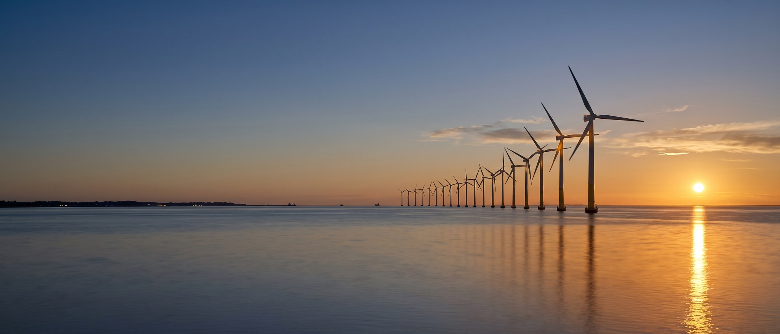
Key visual 1 – offshore (final selection).

5. Channels and budget
Channel | EUR | Share
LinkedIn paid (sponsored content, conversation ads) | 92,000 | 38 %
Digital out-of-home: Hamburg Airport, Edinburgh Waverley | 54,000 | 23 %
Trade press print & online | 31,000 | 13 %
Podcast sponsorship (Energy Transition Talks) | 18,000 | 8 %
Production (photo shoot, video, design) | 35,000 | 15 %
Contingency | 10,000 | 4 %
Total | 240,000 | 100 %

6. Timeline
When | What
May | Photo shoots at Kestrel Ridge, Port of Eastholm, Hamburg office
1 June | Launch – LinkedIn, careers page relaunch
15 June – 15 July | DOOH flight Hamburg Airport / Edinburgh Waverley
September | Summit tie-in (booth B4.210), second LinkedIn burst
October | Results report and decision on 2027 continuation

7. Guardrails
- No campaign content about Millbrook while the planning application is open (agreed with Liam McAllister).
- All site photos checked for correct PPE by HSE (Hannah Weber).
- Figures only from the Annual Report 2025 or approved press releases.

